

Dear [name]  
  
GLinkedIn is finally here!  
  
We made a new app to assistant throughout your journey and help you reach your first dream job. We bring together training and placement under one platform because we want to give you tools to succeed on the professional world 🚀

So, what is GlinkedIn all about?



Your first dream job is waiting for you.   
+3K companies are associated with GLinkedIn to help you to develop your professional growth



Access to learning platforms like Datacamp, Data Scientist 365 and more with +20K expert-led trainings with certifications



Personalized mentoring with the top leaders on the market who are waiting to solve all your questions

Take a tiny look!   
Press play and live the GlinkedIn experience 😉

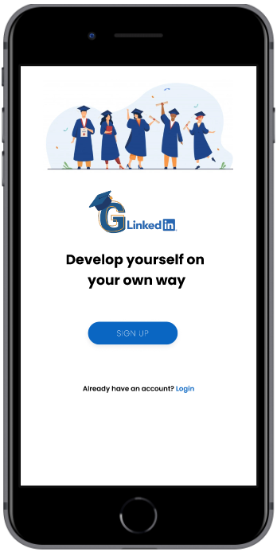



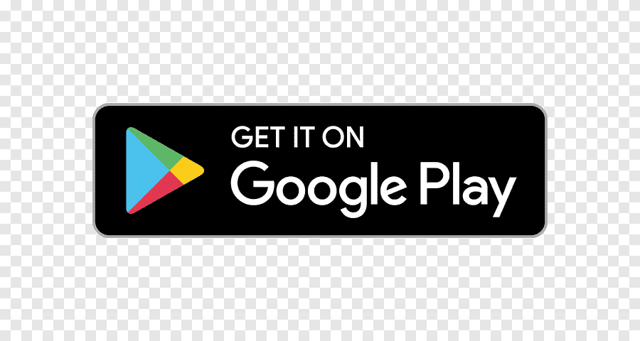

Get the app here

Get the app here

Sincerely,

Team GLinkedIn 🚀